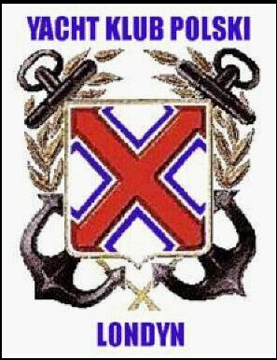
YACHT KLUB POLSKI LONDYN POLSKI YACHT CLUB LONDON (1982)
- Hillside Road
LONDON N15 6LU U .K.
Tel. +44(0)20 8800 7570
Email: ykp@london.com
London, February 23, 2006

The British Museum
Coins and Medals
coins@thebritishmuseum.ac.uk

Dear Sir, Madame,

My name is Tomasz Mazur. I am a member of Yacht Club of Poland London and journalist for internet portal www.pogoria.org I want to ask about very important part of history Yacht Club of Poland. The question is about its Medal which was made in Poland during the occupation of my country by fascist in World War II. This is memorial Medal, tangible proof of sailing competition YKP in Wisla River in year 1943. This competition was illegal and participation was threatened by death.
That medal should be in British Museum collection because one duplicate was given by Madame Eileen Garlinska after World War II. Eileen Garlinska was wife of polish Home Army officer and participant that sailing competition. Madam Garlinska after World War II emigrated from Warsaw and lived in London.

My questions are:
- Does this Medal is in British Museum currently?
- What is this medal made of? Silver or bronze?
- Can I see this medal in British Museum?

I do apologise my English language is not very well.
Yours sincerely,
Tomasz Mazur.

Photos. Medals silver and bronze from book about history of YKP 1924-1999y.
